**Case Study-5:**

**Problem Statement:**

**TASK 1: Build an AWS cost-effective solution to read S3 bucket files present at /out folder. Monitor the incoming .txt file at /out folder and execute application only after getting file at the provided location. Write a script/inline application to count the words present in the .txt file and write it in count.txt file along with the execution date. Update count.txt file to append count and store it at /count folder of S3 bucket.**

**Task 2: Also, to perform cost management develop an application to shut down and start dev account EC2 instances on 6PM and 9PM every day respectively.**

**Task 3 :Also, you have been tasked with identifying 14 days (about 2 weeks) older EBS volumes snapshot and automate the process to delete those on weekly basis.**

--------------------------------------------------------------

TASK 1:

# Architecture Components

1. S3 Bucket with folders: /out and /count  
2. Lambda Function triggered by S3 Event Notifications  
3. IAM Role and Policy for Lambda S3 access  
4. Terraform to deploy all infrastructure using variables

# Terraform Files and Structure

.  
├── main.tf  
├── variables.tf  
├── outputs.tf  
├── lambda/  
│ └── lambda_function.py

**CASE 5: Deliverables:**



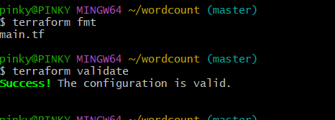

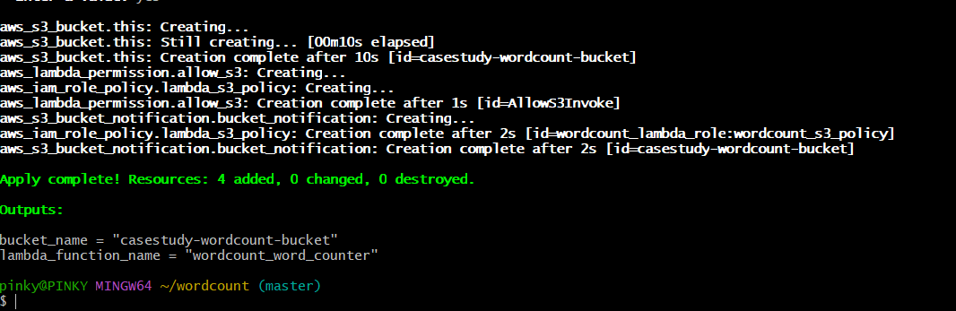

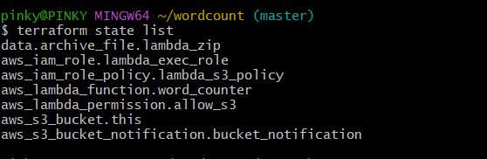

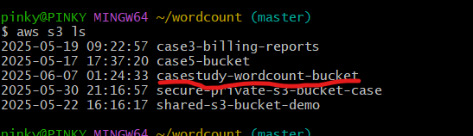

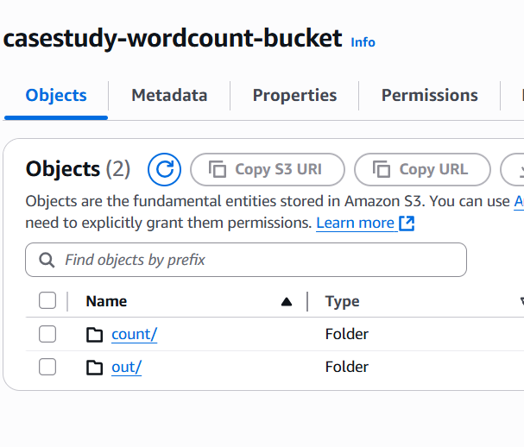

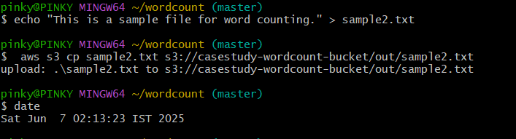

**As soon as I upload sample2.txt file in the out folder 🡪count.txt file counts words :**

**Check the date and timestamp:**

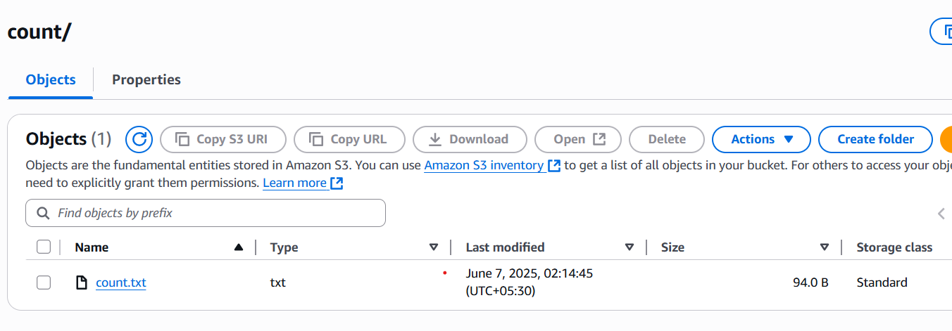

**Below is the count.txt**

[**https://casestudy-wordcount-bucket.s3.us-east-1.amazonaws.com/count/count.txt**](https://casestudy-wordcount-bucket.s3.us-east-1.amazonaws.com/count/count.txt)



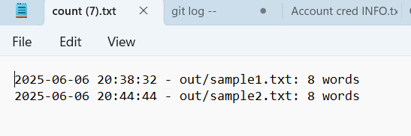

**CASE study5: TASK2:**

To perform cost management develop an application to **shut down and start** dev account EC2 instances on 6PM and 9PM every day respectively

**9 AM and 6 PM IST → 3:30 AM and 12:30 PM UTC**

1. **A Lambda function**
2. **An IAM role with proper permissions**
3. **Two EventBridge rules (for 9 AM and 6 PM IST → 3:30 AM and 12:30 PM UTC)**

**Created all above using terraform**

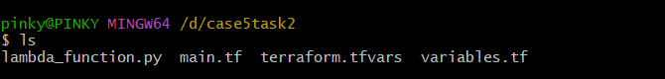

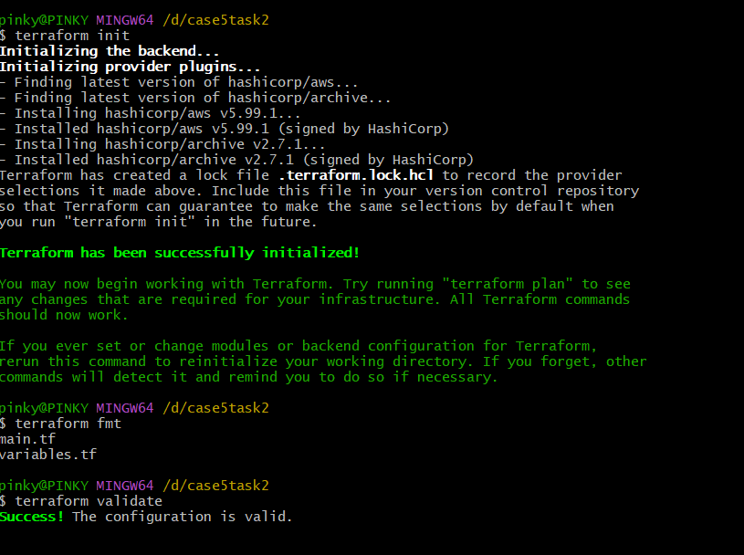



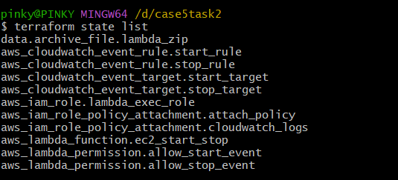

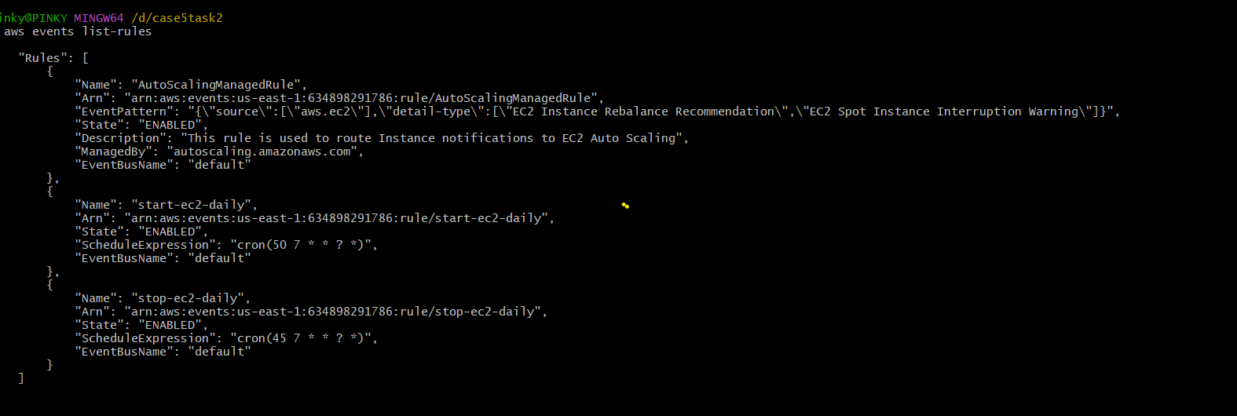

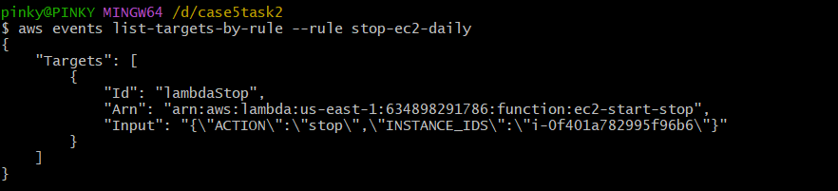

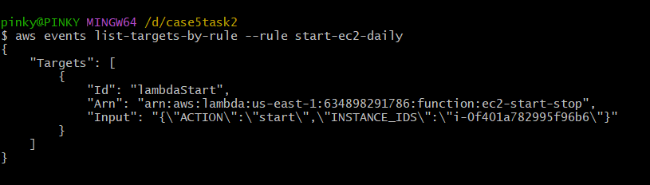

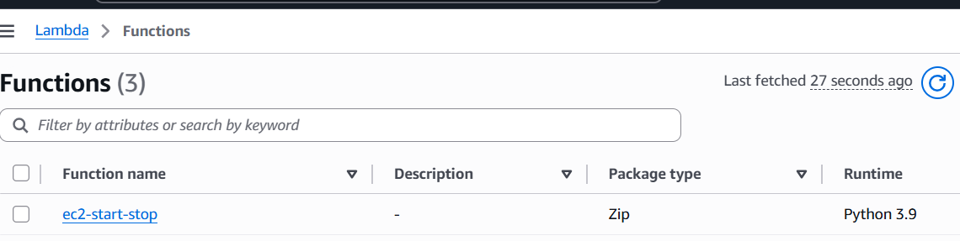

**Lambda function has been created.**

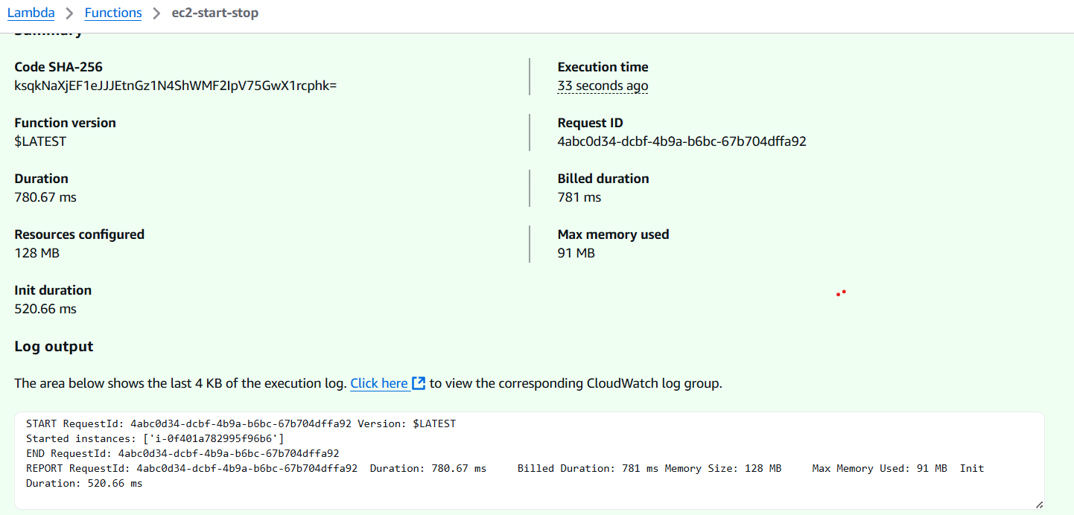

**Just tested lambda function using test event above is the screenshots**

**Imstance was in stopped condition . started the given the event for starting**

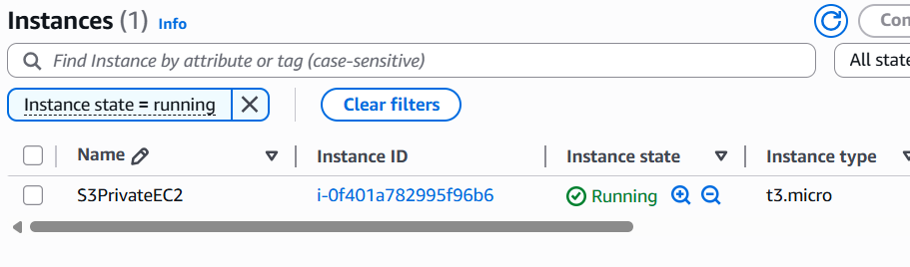

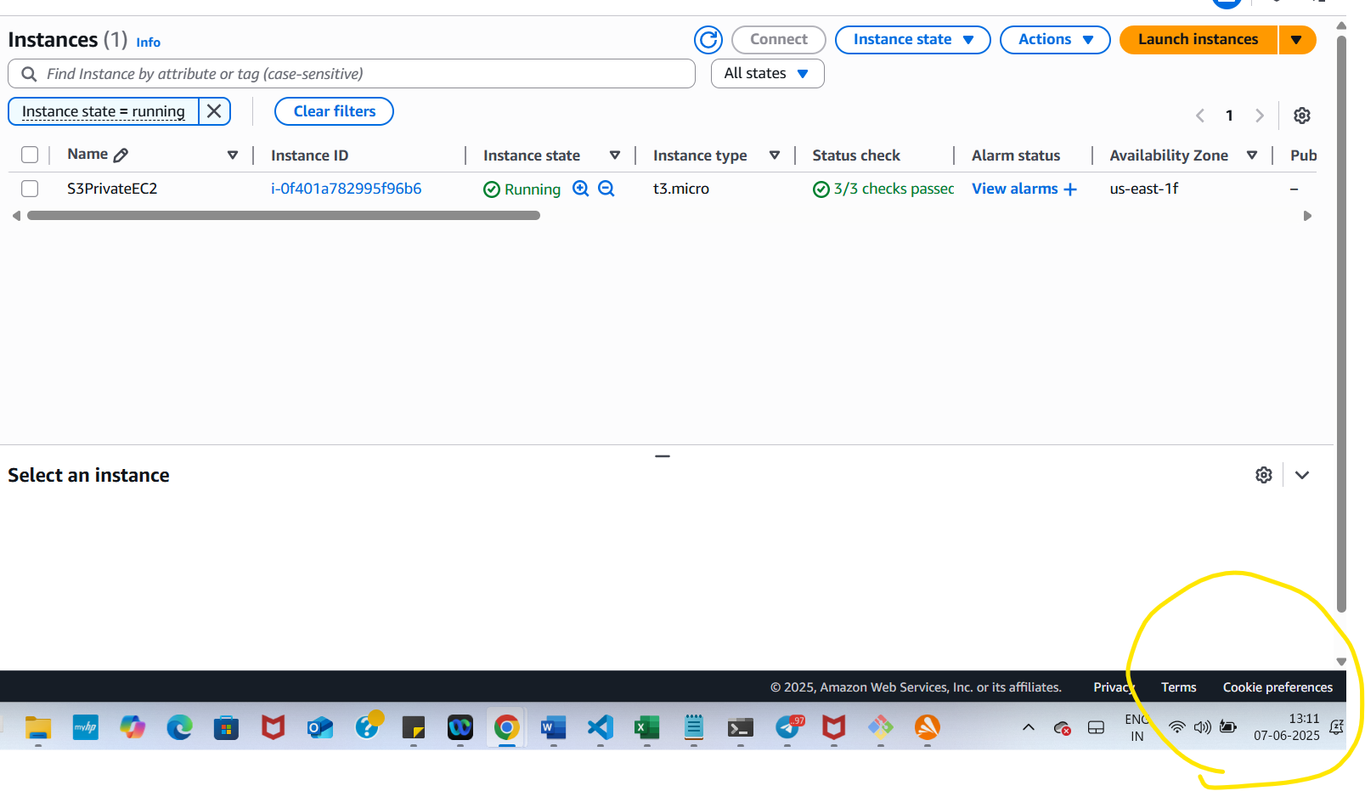

**13.11 PM it is running**

**I given terraform apply command waited until 13:15 pm**

**13.15 it has to stop**

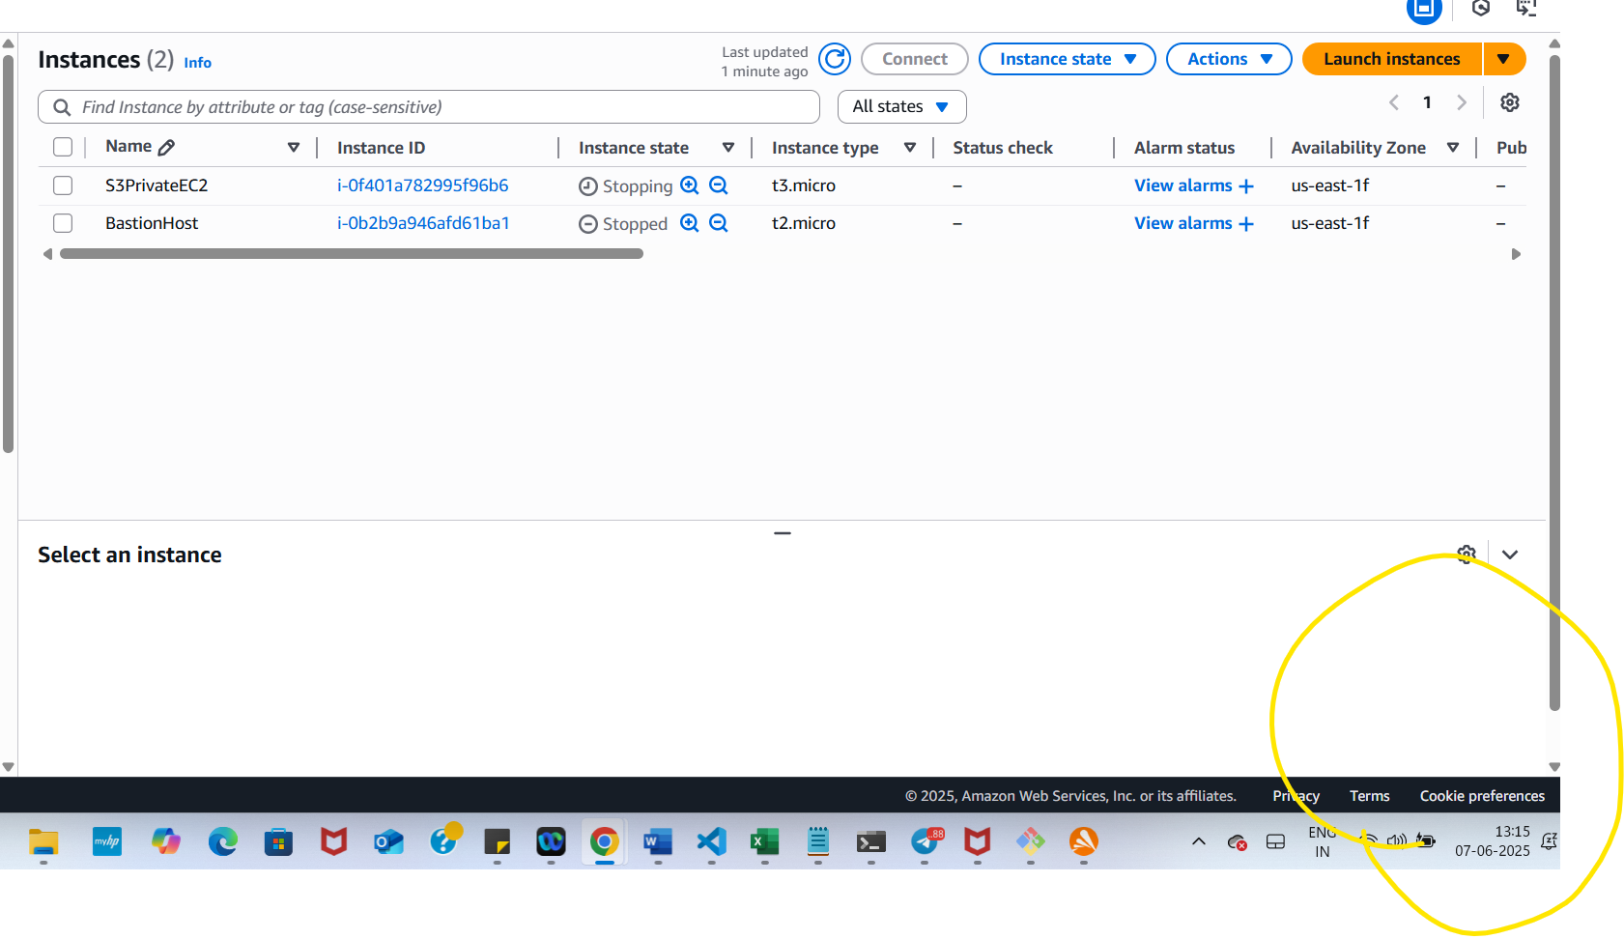

**13.15 instance state has been changed to stopping 🡪 see the timings.**

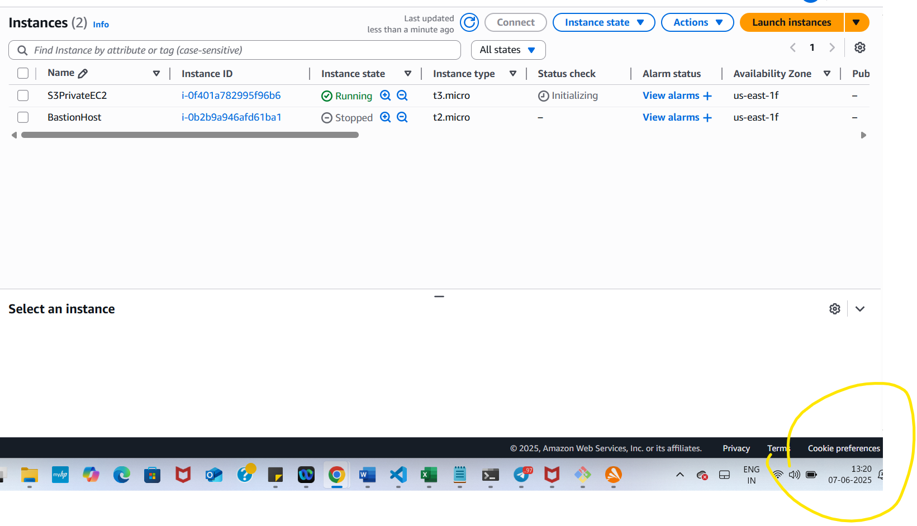

**13.20 instance state has been changed to running 🡪 see the timings.**

**Since I changed timings for my easiness to (13.15 pm and 13.20 pm IST)instead of**

**( 9AM and 6 PM IST )**

**After Taking screenshots and changed the timings in the script uploaded to git folder.**

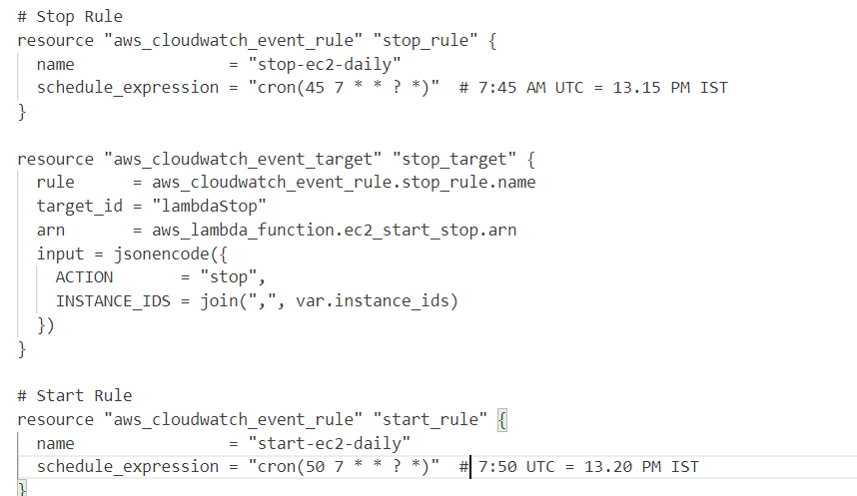

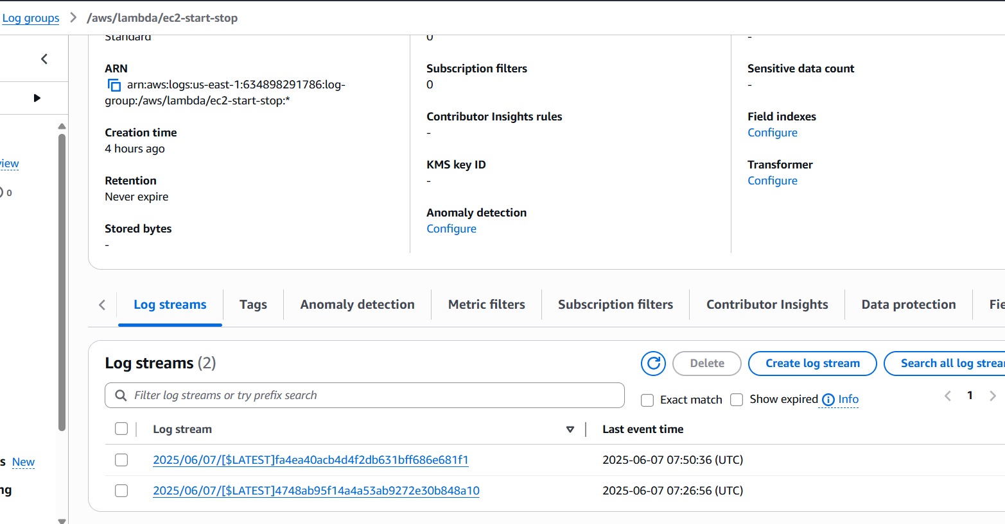

Case 5 task 3:

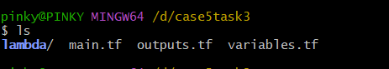

Create an **IAM role and policy** for the Lambda.

Deploy the **Lambda function** to delete EBS snapshots older than 14 days.

Create a **CloudWatch EventBridge rule** to run the Lambda **every week**.

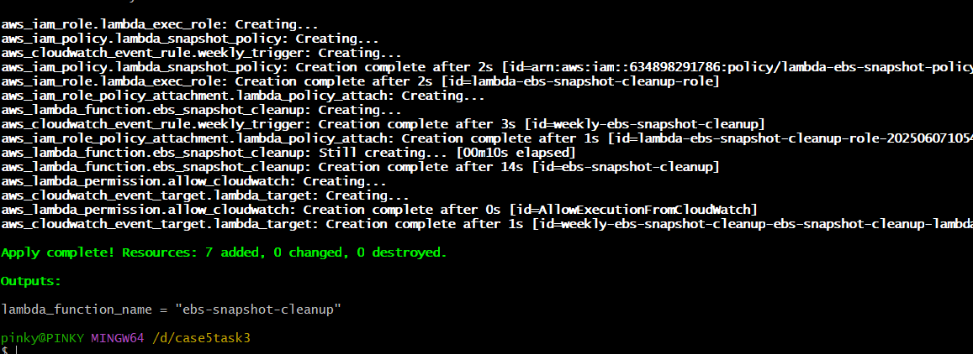

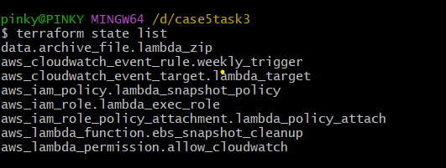

Manual Invocation Test using aws cli.

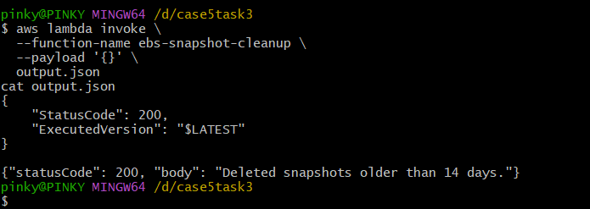

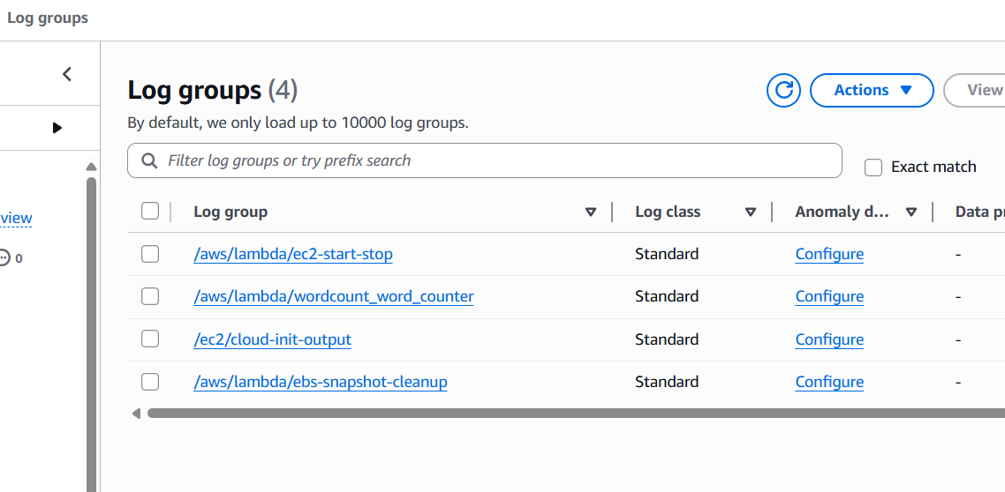

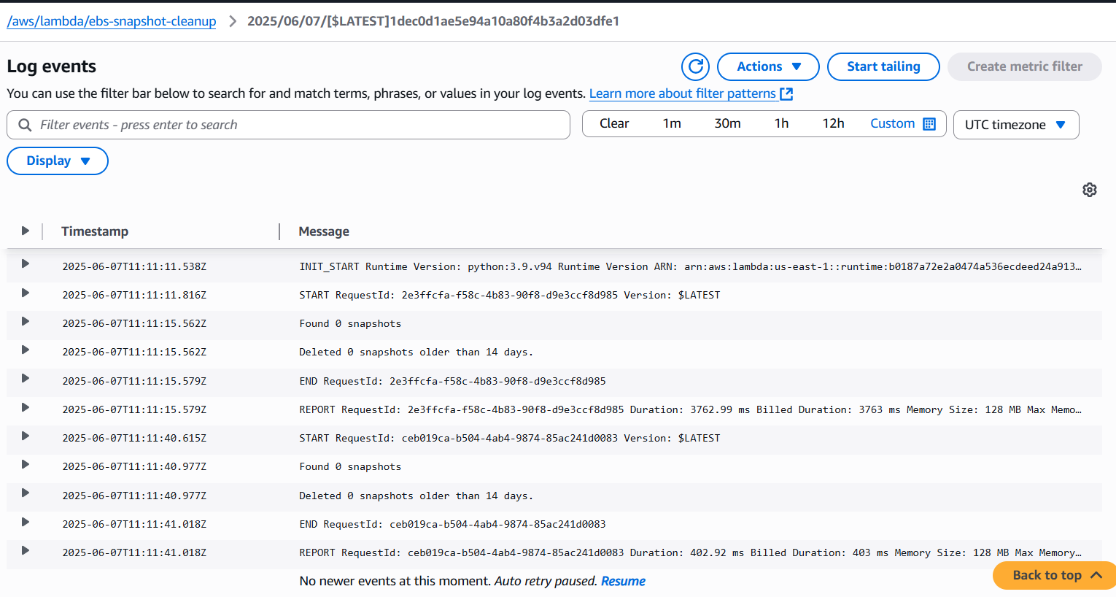

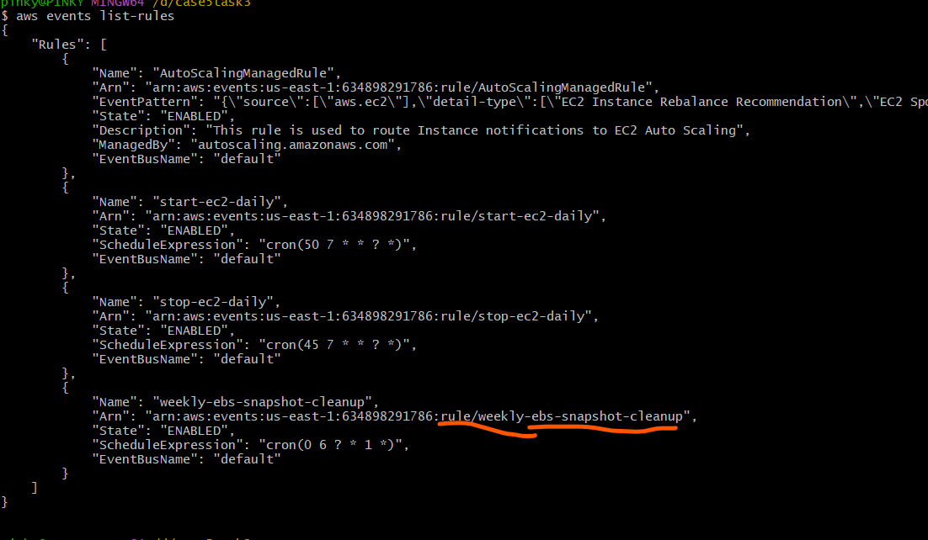

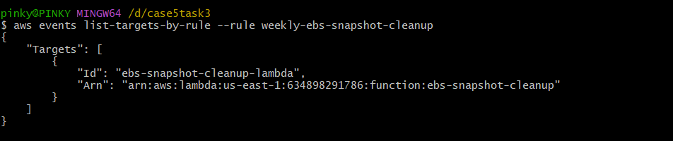

Volume id vol-0b1da8c10a885d9dc

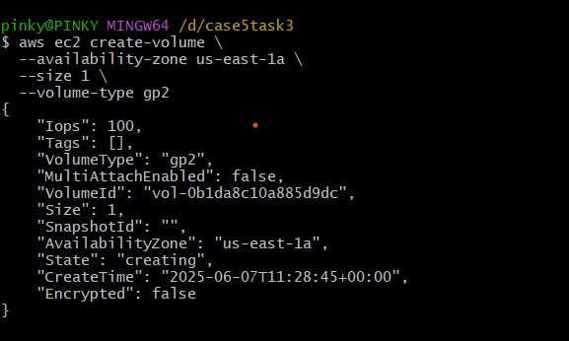

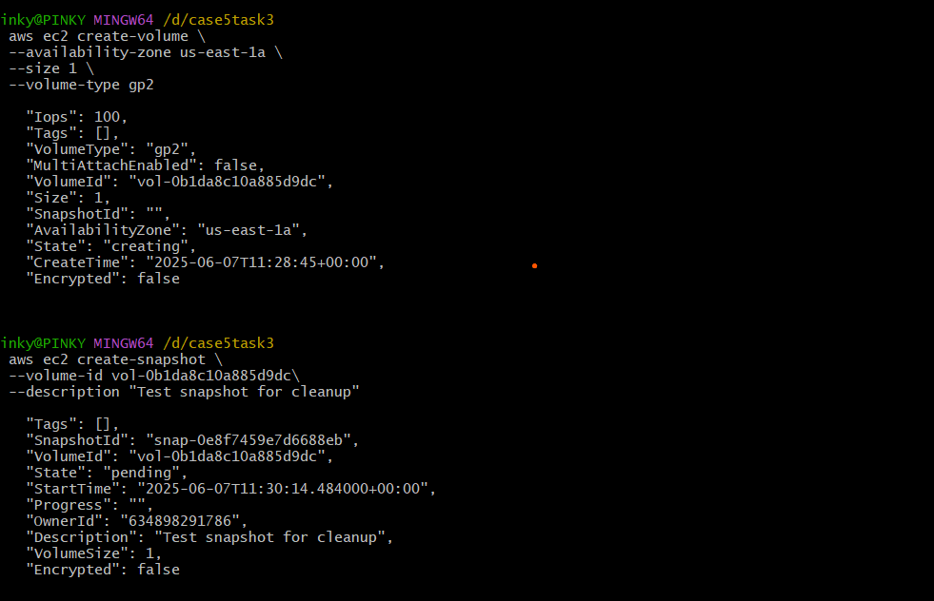

Changed the snapshots age >=0

To test the manually created snapshots today.changed settings like that in lambda function:

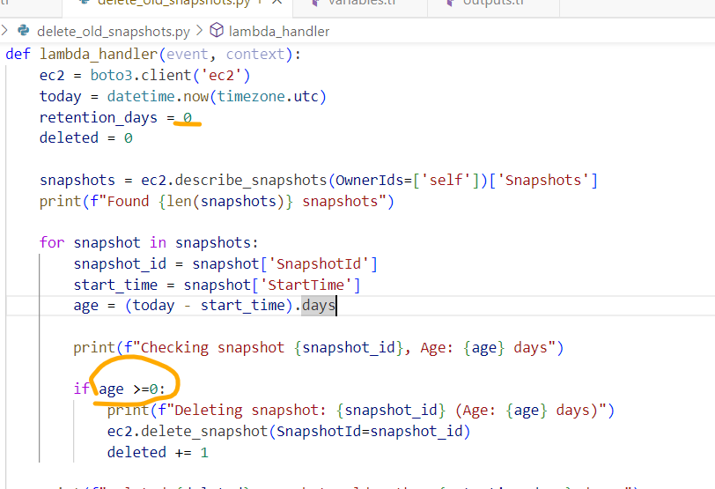

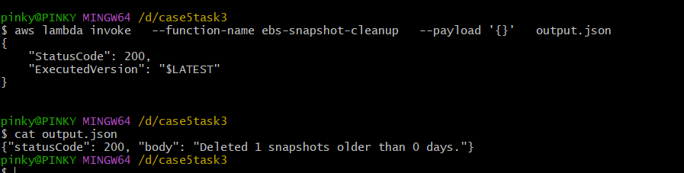

And then invoke the lambda again it got deleted recent the snapshots as above..

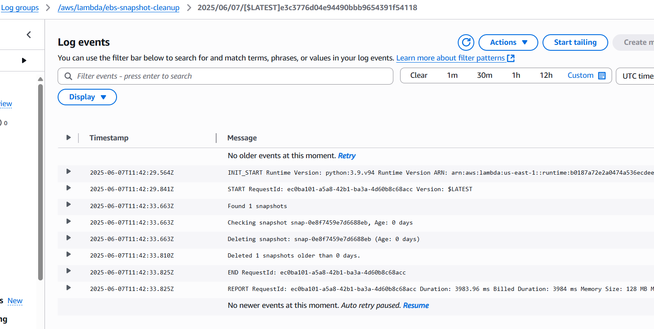

It deleted the snapshots which I was created earlier check snapshot iD.

